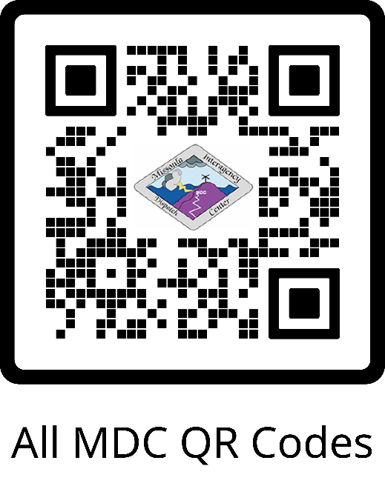

**Western US Dispatch**

**Boundaries**

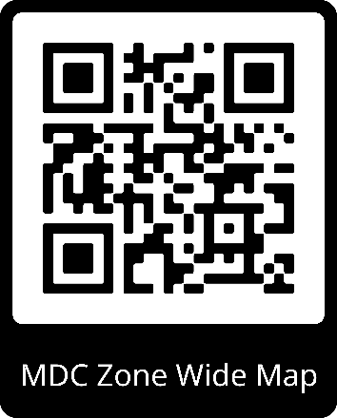

**Missoula Dispatch Layers (.kmz)**

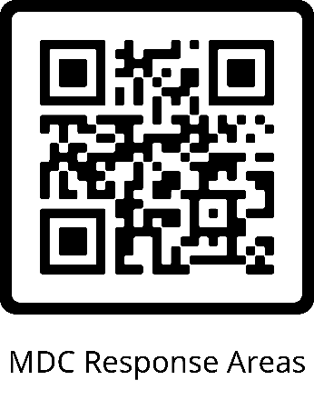

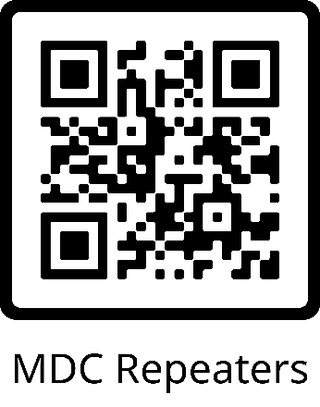 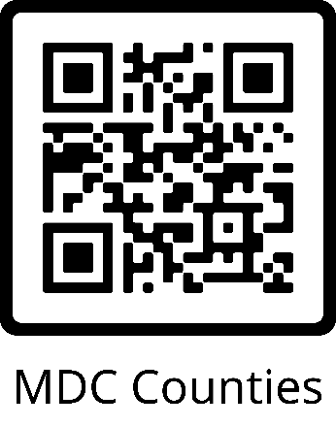

**Aviation**

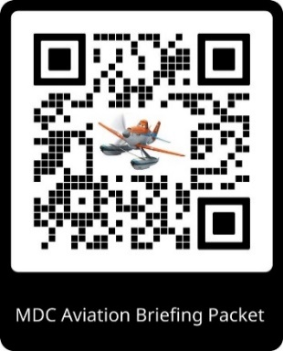 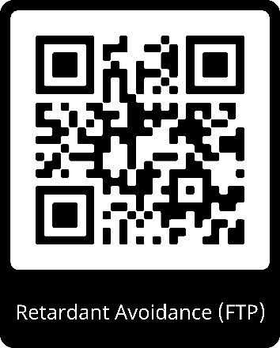 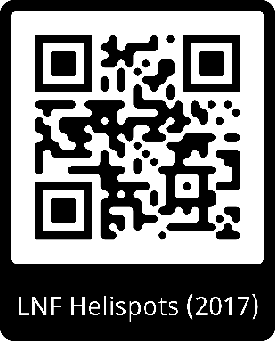

**Admin-Use Only QR Codes for Avenza**

***NOT UNDER OPERATIONAL CONTROL OF MDC***

Please visit the [USFS Data, Information, and Geospatial SharePoint](https://usdagcc.sharepoint.com/sites/fs-r01-digeo/SitePages/Avenza.aspx) to view the most recent maps.   
This site is available only to USFS employees.

